**Cross Hedging of Cryptocurrency**

Rohit Garg ([f2005636@gmail.com](mailto:f2005636@gmail.com))

**Cryptocurrency**

A cryptocurrency a digital asset designed to work as a medium of exchange that uses cryptography to secure its transactions. Cryptocurrencies are classified as a subset of digital currencies and are also classified as a subset of alternative currencies and virtual currencies.

**Figure 1: How Cryptocurrency works**

**The economics behind cryptocurrency:** Cryptocurrency is essentially a fiat currency. This means users must reach a consensus about cryptocurrency's value and use it as an exchange medium. However, because it is not tied to a particular country, its value is not controlled by a central bank. With bitcoin, the leading functioning example of cryptocurrency, value is determined by market supply and demand, meaning that it behaves much like precious metals, like silver and gold. Cryptocurrency is designed to bring back a "decentralized currency of the people", taking centralized banks out of the equation. Because bitcoins must be cryptographically signed each time they are transferred, each bitcoin user has both public and individual private keys.

**Possible abuse of crypto currencies:** Cryptocurrency transactions are anonymous, untraceable and have created a niche for illegal transactions, like drug trafficking. Because the currency has no central repository, law enforcement and payment processors have no jurisdiction over bitcoin accounts. For cryptocurrency supporters, this anonymity is a primary strength of this technology, despite the potential for illegal abuse, as it enables a shift in power from institutions to individuals.

**Types of Cryptocurrencies:** Although there are technically over 1000 cryptocurrencies, only few are discussed below:

**Figure 2: Types of Cryptocurrencies**

|  |  |
| --- | --- |
| Prevailing bitcoin logo | **Bitcoin (BTC)**: Bitcoin is the first decentralized digital currency, as the system works without a central bank or single administrator. It has the highest market cap, its coins generally trade at the highest cost of all cryptocurrencies. Bitcoins are created as a reward for a process known as mining. |
| C:\Users\rg83892\Desktop\download.png | **Ethereum (ETH):** Ether is a cryptocurrency whose blockchain is generated by the Ethereum platform. Ether can be transferred between accounts and used to compensate participant mining nodes for computations performed. It doesn’t have the longevity at the top like Litecoin, but it is built on a system that other coins are built on. Most ICOs (Initial Coin Offerings) use ethereum. |
| Ripple logo.svg | **Ripple (XRP):** Ripple was released in 2012, Ripple purports to enable secure, instantly and nearly free global financial transactions of any size with no chargebacks. Ripple tends to have a steady price due to its large supply. It has had staying power over time. |
| 6 Full Logo S-2.png | **Litecoin (LTC):** Litecoin is a peer-to-peer cryptocurrency and open source software project released under the MIT/X11 license. The Litecoin Network aims to process a block every 2.5 minutes, rather than Bitcoin's 10 minutes. The developers claim that this allows Litecoin to have faster transaction confirmation. |
| Monero-Logo.svg | **Monero (XMR):** Monero is an open-source cryptocurrency created in April 2014 that focuses on privacy and decentralization that runs on Windows, macOS, Linux, Android, and FreeBSD. Monero uses a public ledger to record transactions while new units are created through a process called mining. |
| https://upload.wikimedia.org/wikipedia/en/thumb/a/a6/Dash_%28cryptocurrency%29_logo.svg/220px-Dash_%28cryptocurrency%29_logo.svg.png | **DASH (DASH):** Dash is an open source peer-to-peer cryptocurrency. On top of Bitcoin's feature set, it currently offers instant transactions, private transactions and operates a self-governing and self-funding model that enables the Dash network to pay individuals and businesses to perform work that adds value to the network. |
| NEM (cryptocurrency) logo.svg | **NEM (XEM):** NEM was launched on March 31, 2015. NEM has a stated goal of a wide distribution model and has introduced new features to blockchain technology such as its proof-of-importance (POI) algorithm, multisignature accounts, encrypted messaging, and an Eigentrust++ reputation system. |

**Data Summary**

Time series analysis is concerned with the analysis of data collected over time. Adjacent observations are typically dependent. Time series analysis hence deals with techniques for the analysis of this dependence.

**We create a zoo objects called btc from the daily closing prices of Bitcoin and ltc from the daily closing prices of Litecoin which are stored in the CSV files.** Each line on the sheet contains a date and a closing price separated by a comma. The first line contains the column headings (Date and Close). To get a first impression of the data, we plot the price chart:

**Figure 3: Closing prices of Bitcoin (BTC) and Litecoin (LTC)**

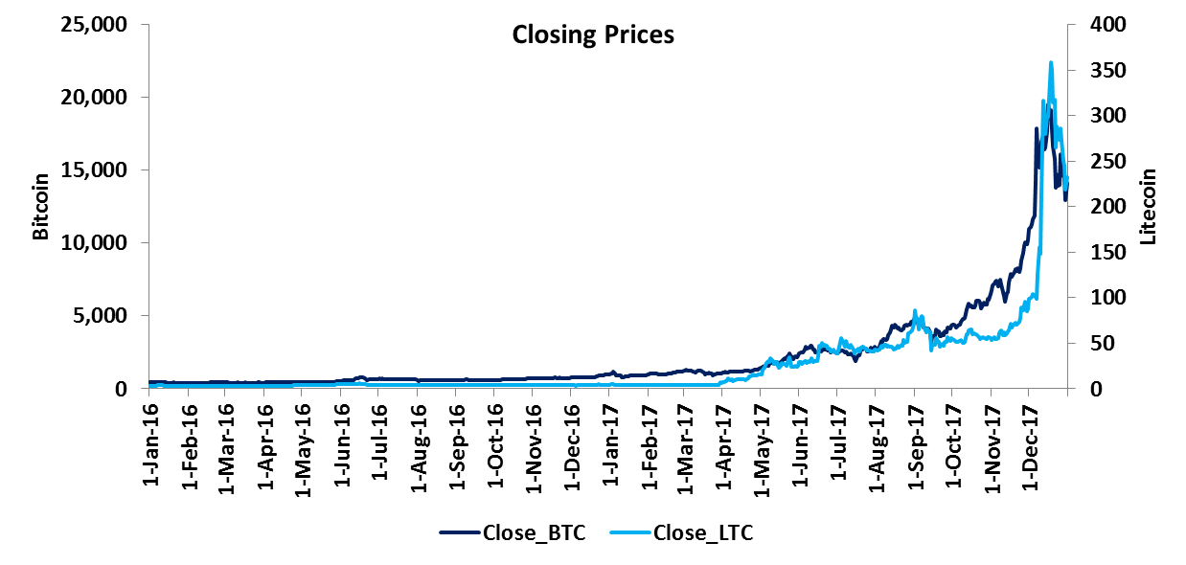

**Table 1: Date Range and Data Range**



When dealing with time series, one is normally more interested in returns instead of prices. This is because returns are usually stationary. So we will calculate continuously compounded returns:

**ret_btc = diff(log(btc)) * 100**

**ret_ltc = diff(log(ltc)) * 100**

**Cross Hedging Bitcoin**

Since the price of Bitcoin can be volatile, most investors should hedge at least part of their exposure to Bitcoin price changes. In the absence of Bitcoin OTC instruments, investors can use related cryptocurrencies for hedging purposes. In this example Litecoin has been used to hedge.

**Cointegration: The idea behind cointegration is to find a linear combination between non-stationary time series that result in a stationary time series. It is hence possible to detect stable long-run relationships between non-stationary time series.**

Testing Bitcoin for stationarity: The null hypothesis of non-stationarity (Bitcoin time series contains a unit root) cannot be rejected at the 1% significance level

**Table 2: Testing Bitcoin for stationarity**



Testing Litecoin for stationarity: The null hypothesis of non-stationarity (Litecoin time series contains a unit root) cannot be rejected at the 1% significance level

**Table 3: Testing Litecoin for stationarity**



**Now we try to estimate the hedge ratio by using an existing long-run relationship between the levels of Bitcoin and Litecoin prices. We obtain a hedge ratio of 61.23.**

**Table 4: Estimating hedge ratio**



Testing error for stationarity: The null hypothesis of non-stationarity is rejected at the 1% significance level

**Table 5: Testing error for stationarity**



**Cryptocurrency Portfolio Optimization**

Rohit Garg ([f2005636@gmail.com](mailto:f2005636@gmail.com))

**Cryptocurrencies**

A cryptocurrency a digital asset designed to work as a medium of exchange that uses cryptography to secure its transactions. Cryptocurrencies are classified as a subset of digital currencies and are also classified as a subset of alternative currencies and virtual currencies.

For demonstration purposes, we have fetched the following cryptocurrencies from Kaggle dataset (https://www.kaggle.com/sudalairajkumar/cryptocurrencypricehistory/data). The observation window is from 20-Aug-2016 to 20-Feb-2018.

* Bitcoin (BTC)
* Ethereum (ETH)
* Ripple (XRP)
* Litecoin (LTC)
* Monero (XMR)
* DASH (DASH)
* NEM (XEM)

|  |  |
| --- | --- |
| **R Code to calculate the continuous returns** | assets = data[, -1]  return = log(tail(assets, -1) / head(assets, -1)) |

**Table 1: Data Summary of Close Price**



**Table 2: Data Summary of Returns**



**Table 3: Comparison of Volatility with NASDAQ Composite**



**Figure 1: Close Price and Daily Return**

|  |  |  |
| --- | --- | --- |
| **Bitcoin (BTC)**  Prevailing bitcoin logo |  |  |
| **Ethereum (ETH)**  C:\Users\rg83892\Desktop\download.png |  |  |
| **Ripple (XRP)**  Ripple logo.svg |  |  |
| **Litecoin (LTC)**  6 Full Logo S-2.png |  |  |
| **Monero (XMR)**  Monero-Logo.svg |  |  |
| **DASH (DASH)**  https://upload.wikimedia.org/wikipedia/en/thumb/a/a6/Dash_%28cryptocurrency%29_logo.svg/220px-Dash_%28cryptocurrency%29_logo.svg.png |  |  |
| **NEM (XEM)**  NEM (cryptocurrency) logo.svg |  |  |

**Minimum Variance Portfolio**

For the mathematical formulation of Mean-Variance model by Markowitz, we need some definitions. They are explained as follows:

* By asset Xi, we mean a random variable with finite variance.
* By portfolio, we mean the combination of assets: P =­ ΣwiXi , where Σ­wi = 1
* By optimization, we mean a process of choosing the best wi coefficients (weights) so that our portfolio meets our needs (that is, it has a minimal risk on the given expected return or has the highest expected return on a given level of risk).

|  |  |
| --- | --- |
| **R Code to check the head and tail of return** | head(return)  tail(return) |

**Table 4: Head of Return Dataframe**



**Table 5: Tail of Return Dataframe**



Minimum variance on a desired level of return: It is clear that wTQw is the variance of the portfolio and wr is the expected return. For the sum of the weights we have w1 =1, which means that we would like to invest 1 unit of cash.

**Equation 1: Minimum Variance**



It can be shown that this problem is equivalent to the following system of linear equations. Two rows and two columns are added to the covariance matrix, so we have conditions to determine the two Lagrange multipliers as well. We can expect a unique solution for this system.

**Equation 2: Linear Equation**

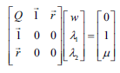

We start building the left side of the linear equality system specified at the Lagrange theorem, where we combine the covariance matrix (cov), ones repeated (rep) by the number of columns (ncol) in the dataset and the means (colMeans) of the returns as rows (rbind). Now, we also combine the last two rows of the matrix (tail) as new columns (rbind) on the left to make it complete for the linear system with the extra zeros specified in the Lagrange theorem (matrix of 2x2):

|  |  |
| --- | --- |
|  | Q = rbind(cov(return), rep(1, ncol(assets)), colMeans(return))  Q = cbind(Q, rbind(t(tail(Q, 2)), matrix(0, 2, 2)))  round(Q, 5) |

**Table 6: Left Part of the Equation**



Next, we build the right side of the linear equality system. Expected return (mu) is 0.005 and ones repeated (rep) by the number of columns (ncol):

|  |  |
| --- | --- |
|  | mu = 0.005  b = c(rep(0, ncol(assets)), 1, mu)  round(b, 5) |

**Table 7: Right Part of the Equation**



After successfully building the parts of the linear equality system, we are only left with the task of solving it. The result is the vector of optimal weights and the Lagrange multipliers to get the desired expected return with a minimal variance:

|  |  |
| --- | --- |
|  | w = solve(Q, b)  round(w,5) |

**Table 8: Weights**



**Tangency Portfolio**

If R (riskless asset) is added to X (any risky portfolio); then those portfolios form a straight line on the mean-standard deviation plane. Any portfolio on this line is available by investing into R and X. It is clear that the best choice for X is the point where this line is tangent to Efficient Frontier. This tangency point is called the market portfolio or tangency portfolio, and the tangent of Efficient Frontier of risky assets at this point is called Capital Market Line (CML), which consists of the efficient portfolios of all the assets in this case.

**Figure 2: Tangency Portfolio**

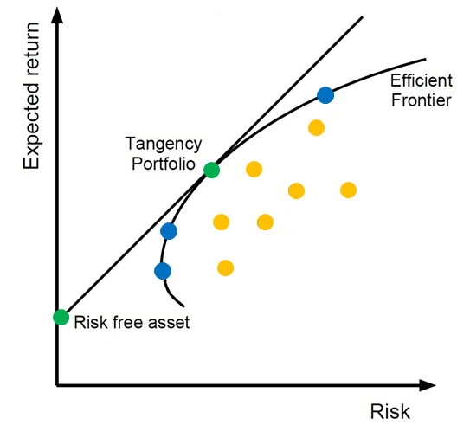

We can easily modify the variance minimization code to accomplish this. First of all, if we add a riskless asset, a full-zero row and column is added to the covariance matrix (where n is the number of assets including the riskless one). Then the riskless return (let rf be 0.0001) is added to the return vector.

|  |  |
| --- | --- |
|  | Q = cbind(cov(return), rep(0, n - 1))  Q = rbind(Q, rep(0, n))  Q = rbind(Q, rep(1, n), r)  Q = cbind(Q, rbind(t(tail(Q, 2)), matrix(0, 2, 2)))  round(Q, 5) |

**Table 9: Left Part of the Equation**



Next, we build the right side of the linear equality system. Expected return (mu) is 0.005 and ones repeated (rep) by the number of columns (ncol):

|  |  |
| --- | --- |
|  | mu = 0.005  b = c(rep(0, ncol(assets)), 1, mu)  round(b, 5) |

**Table 10: Right Part of the Equation**



After solving the equation, the result is the market portfolio. The sum of the weights is 1.

|  |  |
| --- | --- |
|  | w = solve(Q, b)  w = head(w, -3)  w / sum(w)  round(w, 5)) |

**Table 11: Weights**



**Summary**

The two approaches discussed in this paper for portfolio optimization are minimum variance portfolio and tangency portfolio. The weights for minimum variance portfolio and the weights for the tangency portfolio:

**Table 12: Weights**



**Asset Pricing Models for Cryptocurrency**

Rohit Garg ([f2005636@gmail.com](mailto:f2005636@gmail.com))

**Cryptocurrency**

A cryptocurrency a digital asset designed to work as a medium of exchange that uses cryptography to secure its transactions. Cryptocurrencies are classified as a subset of digital currencies and are also classified as a subset of alternative currencies and virtual currencies.

**Bitcoin (BTC):** Bitcoin is the first decentralized digital currency, as the system works without a central bank or single administrator. It has the highest market cap, its coins generally trade at the highest cost of all cryptocurrencies. Bitcoins are created as a reward for a process known as mining.

**Figure 1: Bitcoin Close Price and Daily Return**

|  |  |
| --- | --- |
|  |  |

**Ethereum (ETH):** Ether is a cryptocurrency whose blockchain is generated by the Ethereum platform. Ether can be transferred between accounts and used to compensate participant mining nodes for computations performed. It doesn’t have the longevity at the top like Litecoin, but it is built on a system that other coins are built on. Most ICOs (Initial Coin Offerings) use ethereum.

**Figure 2: Ethereum Close Price and Daily Return**

|  |  |
| --- | --- |
|  |  |

**Ripple (XRP):** Ripple was released in 2012, Ripple purports to enable secure, instantly and nearly free global financial transactions of any size with no chargebacks. Ripple tends to have a steady price due to its large supply. It has had staying power over time.

**Figure 3: Ripple Close Price and Daily Return**

|  |  |
| --- | --- |
|  |  |

**Market Portfolio and Risk Free Asset**

A market portfolio is a theoretical bundle of investments that includes every type of asset available in the world financial market, with each asset weighted in proportion to its total presence in the market. The expected return of a market portfolio is identical to the expected return of the market as a whole.

**NASDAQ Composite (IXIC):** The NASDAQ Composite is a stock market index of the common stocks and similar securities listed on the NASDAQ stock market. Along with the Dow Jones Average and S&P 500 it is one of the three most-followed indices in US stock markets. The composition of the NASDAQ Composite is heavily weighted towards information technology companies.

**Figure 4: NASDAQ Close Price and Daily Return**

|  |  |
| --- | --- |
|  |  |

A risk-free asset has a certain future return. Treasuries are considered to be risk-free because they are backed by the U.S. government. Because they are so safe, the return on risk-free assets is very close to the current interest rate.

**LIBOR:** The London Inter-bank Offered Rate is the average of interest rates estimated by each of the leading banks in London that it would be charged were it to borrow from other banks. It was formerly known as BBA Libor (for British Bankers' Association Libor) before the responsibility for the administration was transferred to Intercontinental Exchange. It is the primary benchmark, along with the Euribor, for short-term interest rates around the world.

**Figure 5: LIBOR Close Price and Daily Return**

|  |  |
| --- | --- |
|  |  |

Since spikes were observed for 14-Dec-2017 (obs = 44), 15-Jun-2017 (obs = 171) and 16-Mar-2017 (obs = 234) for Daily Returns of LIBOR, these dates have been removed to avoid outlier effects.

|  |  |
| --- | --- |
| **R Code to calculate exclude the spikes** | * log_return = log(head(assets, -1) / tail(assets, -1)) * return = na.omit(log_return[-c(44,171,234),]) |

**Capital Asset Pricing Model**

The Capital Asset Pricing Model (CAPM) gives an answer to the question asking what can be said of the market by aggregating the rational investors' decisions. The market portfolio contains all securities and the proportion of each security is its market value as a percentage of the total market value. The risk premium on the market depends on the average risk aversion of all market participants. The best-known consequence of the resulting equilibrium is a linear relationship between market risk premium and the individual security's risk:

**Figure 6: Capital Asset Pricing Model**

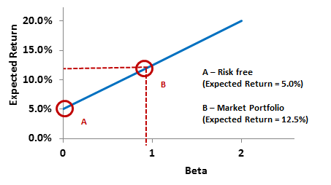

**Equation 1: CAPM Linear Relationship**

E(ri) − rf = βi [E(rm) – rf]

* E(ri) is the expected return of a certain security
* rf is the risk-free return
* E(rm) is the expected return of the market portfolio.

The risk in CAPM is measured by the beta βi, which is a function of the individual security's covariance with the market and the variance of the market return. Beta has numerous interpretations. On the one hand, beta shows the sensitivity of a stock's return to the return of the market portfolio and, on the other, a certain security's beta shows how much risk that security adds to the market portfolio. The CAPM states that the market gives a higher return only in cases of higher systematic risk since unsystematic risk can be diversified, so no risk premium can be paid after that:

**Equation 2: Beta Equation (Approach 1)**

βi = Covi,m / Varm

* Covi,m is the covariance between the given security's return and the market return
* Varm is the variance of the market return.

|  |  |
| --- | --- |
| **R Code to calculate Beta (Approach 1)** | * cov(return$BTC - return$LIBOR, return$IXIC - return$LIBOR) / var(return$IXIC - return$LIBOR) * cov(return$ETH - return$LIBOR, return$IXIC - return$LIBOR) / var(return$IXIC - return$LIBOR) * cov(return$XRP - return$LIBOR, return$IXIC - return$LIBOR) / var(return$IXIC - return$LIBOR) |

**Table 1: Beta Estimates (Approach 1)**



We can use linear regression in order to estimate beta, where the explanatory variable is the Market Risk Premium (MRP), while the dependent variable will be the risk premium of the security. So, the regression equation has the following form, which is the formula for the Security Characteristic Line (SCL). The intercept of the characteristic line is α, the part of the stock return unexplained by the market factor. The slope of the function shows the sensitivity toward the market factor, measured by beta.

**Equation 3: Beta Equation (Approach 2)**

Ri = α + βi Rm + ei

|  |  |
| --- | --- |
| **R Code to calculate Beta (Approach 2)** | * (fit <- lm((return$BTC - return$LIBOR) ~ (return$IXIC - return$LIBOR))) * (fit <- lm((return$ETH - return$LIBOR) ~ (return$IXIC - return$LIBOR))) * (fit <- lm((return$BTC - return$LIBOR) ~ (return$IXIC - return$LIBOR))) |

**Table 2: Beta Estimates (Approach 2)**



**Figure 7: Scattered Plots**

|  |  |
| --- | --- |
| **Bitcoin (Beta = 1.511):**  Start Date – 22-Feb-2017  End Date – 16-Feb-2017  Y Axis – Bitcoin Returns - Rf  X Axis – NASDAQ Returns - Rf  y = 1.511x + 0.0079  R² = 0.036 |  |
| **Ethereum (Beta = 2.1209):**  Start Date – 22-Feb-2017  End Date – 16-Feb-2017  Y Axis – Ethereum Returns - Rf  X Axis – NASDAQ Returns - Rf  y = 2.1209x + 0.0146  R² = 0.0328 |  |
| **Ripple (Beta = 2.0193):**  Start Date – 22-Feb-2017  End Date – 16-Feb-2017  Y Axis – Ripple Returns - Rf  X Axis – NASDAQ Returns - Rf  y = 2.0193x + 0.0175  R² = 0.0152 |  |